Interior Angle Sum Theorem
# Source: AI Source: Provided by: [Data Path: Persons Table -> ID Column: 1, Name_En Column: Motasem Essam] -> From: [ChatGPT] on [7/25/2026]
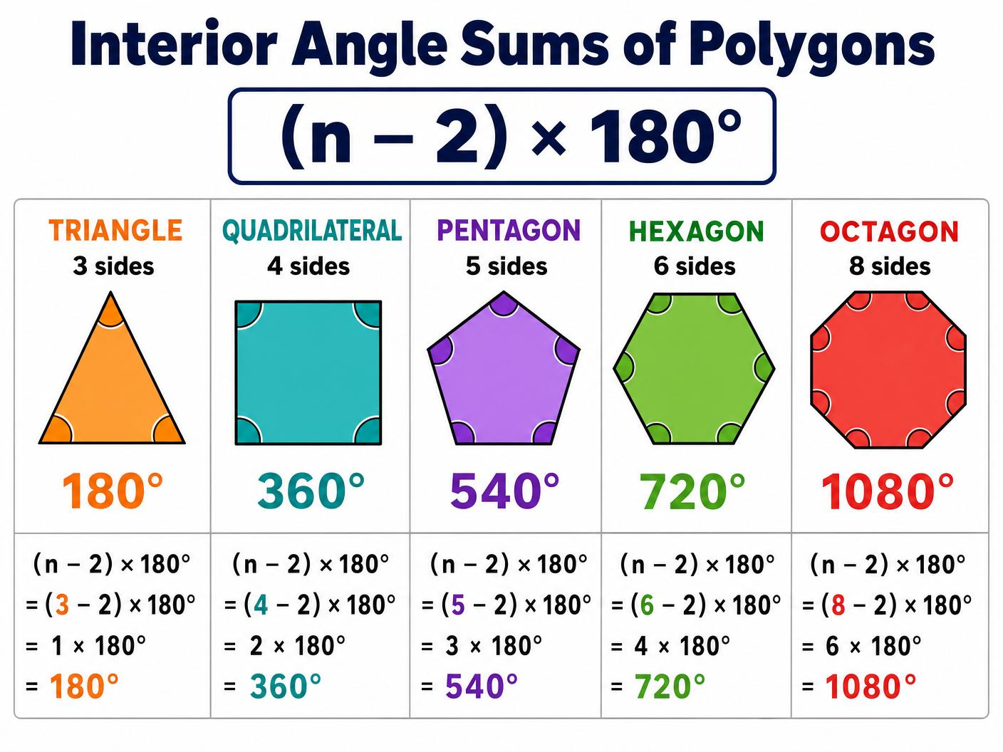
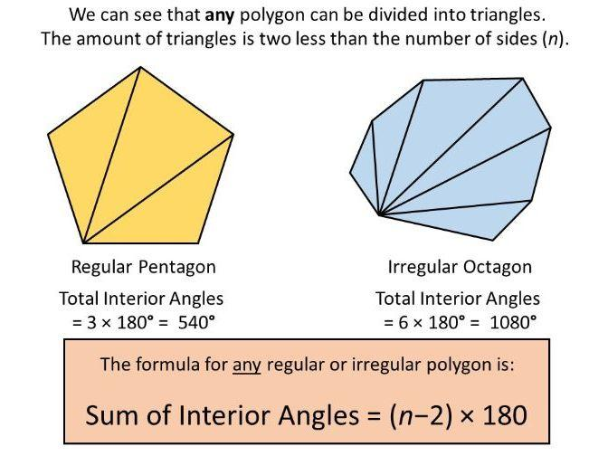
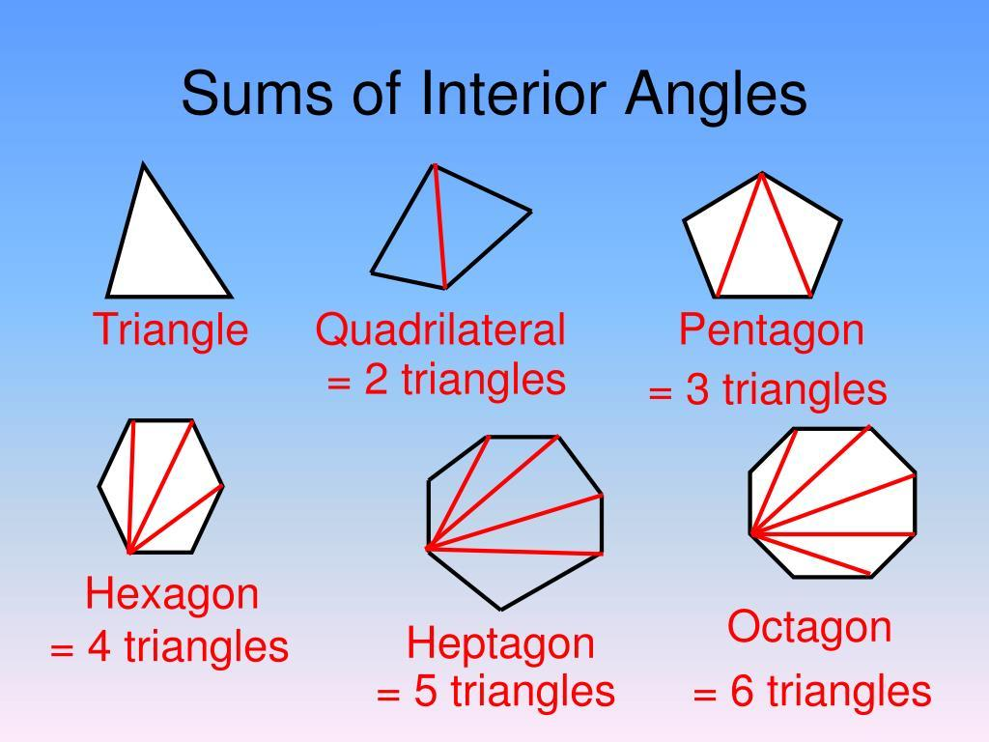
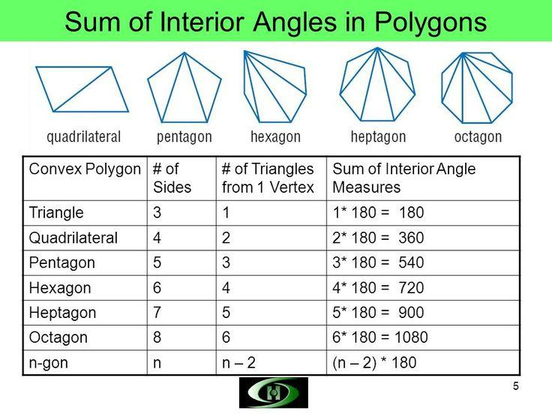

Definition
# Source: AI Source: Provided by: [Data Path: Persons Table -> ID Column: 1, Name_En Column: Motasem Essam] -> From: [ChatGPT] on [7/25/2026]
The Interior Angle Sum Theorem states that the sum of the measures of the interior angles of a simple polygon with $n$sides is:
$$\boxed{\left(n-2\right)×{180}^{∘}}$$
where $n$is the number of sides of the polygon.
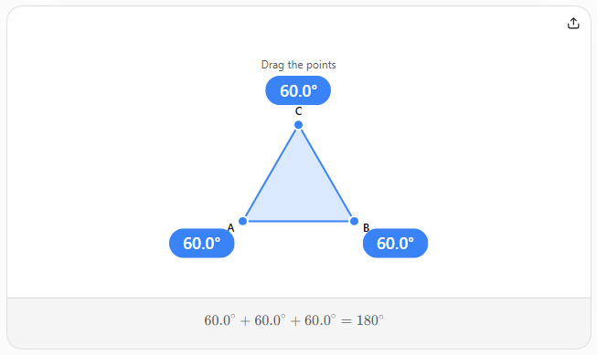

Formula
# Source: AI Source: Provided by: [Data Path: Persons Table -> ID Column: 1, Name_En Column: Motasem Essam] -> From: [ChatGPT] on [7/25/2026]
For an $n$-sided polygon:
$$\boxed{S=\left(n-2\right){180}^{∘}}$$
where:
- $S$= sum of the interior angles
- $n$= number of sides

Why the Formula Works
# Source: AI Source: Provided by: [Data Path: Persons Table -> ID Column: 1, Name_En Column: Motasem Essam] -> From: [ChatGPT] on [7/25/2026]
A simple polygon can be divided into triangles by drawing diagonals from one vertex.
An $n$-gon can be divided into:
$$n-2$$
triangles.
Since every triangle has an angle sum of:
$${180}^{∘}$$
the polygon's interior-angle sum is:
$$S=\left(n-2\right)\left({180}^{∘}\right)$$

Examples
# Source: AI Source: Provided by: [Data Path: Persons Table -> ID Column: 1, Name_En Column: Motasem Essam] -> From: [ChatGPT] on [7/25/2026]
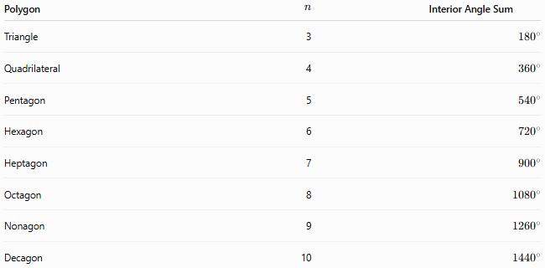
Polygon | $$n$$ | Interior Angle Sum
Triangle | 3 | $${180}^{∘}$$
Quadrilateral | 4 | $${360}^{∘}$$
Pentagon | 5 | $${540}^{∘}$$
Hexagon | 6 | $${720}^{∘}$$
Heptagon | 7 | $${900}^{∘}$$
Octagon | 8 | $${1080}^{∘}$$
Nonagon | 9 | $${1260}^{∘}$$
Decagon | 10 | $${1440}^{∘}$$

Example: Pentagon
# Source: AI Source: Provided by: [Data Path: Persons Table -> ID Column: 1, Name_En Column: Motasem Essam] -> From: [ChatGPT] on [7/25/2026]
For a pentagon:
$$n=5$$
Therefore:
$$S=\left(5-2\right){180}^{∘} \\ S=3\left({180}^{∘}\right) \\ \boxed{S={540}^{∘}}$$

Regular Polygon
# Source: AI Source: Provided by: [Data Path: Persons Table -> ID Column: 1, Name_En Column: Motasem Essam] -> From: [ChatGPT] on [7/25/2026]
If the polygon is regular, all its interior angles are equal.
Therefore, each interior angle is:
$$\boxed{I=\frac{\left(n-2\right){180}^{∘}}{n}}$$
For example, a regular hexagon:
$$I=\frac{\left(6-2\right){180}^{∘}}{6} \\ I=\frac{{720}^{∘}}{6} \\ \boxed{I={120}^{∘}}$$

Relationship to Triangulation
# Source: AI Source: Provided by: [Data Path: Persons Table -> ID Column: 1, Name_En Column: Motasem Essam] -> From: [ChatGPT] on [7/25/2026]
The theorem is directly connected to polygon triangulation:
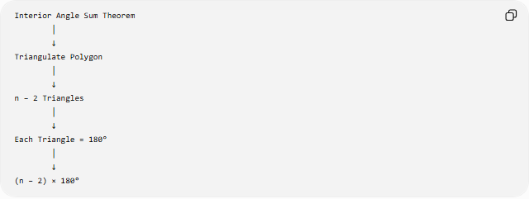
Interior Angle Sum Theorem
│
↓
Triangulate Polygon
│
↓
n − 2 Triangles
│
↓
Each Triangle = 180°
│
↓
(n − 2) × 180°

Important Conditions
# Source: AI Source: Provided by: [Data Path: Persons Table -> ID Column: 1, Name_En Column: Motasem Essam] -> From: [ChatGPT] on [7/25/2026]
The standard formula
$$\left(n-2\right){180}^{∘}$$
applies directly to simple polygons.
For a self-intersecting polygon, such as a pentagram, the ordinary interior-angle interpretation is different because the boundary crosses itself.

Related Formulas
# Source: AI Source: Provided by: [Data Path: Persons Table -> ID Column: 1, Name_En Column: Motasem Essam] -> From: [ChatGPT] on [7/25/2026]
Interior Angle Sum
$$\boxed{S=\left(n-2\right){180}^{∘}}$$
One Interior Angle of a Regular Polygon
$$\boxed{I=\frac{\left(n-2\right){180}^{∘}}{n}}$$
Sum of Exterior Angles
For a simple convex polygon:
$$\boxed{{360}^{∘}}$$
One Exterior Angle of a Regular Polygon
$$\boxed{E=\frac{{360}^{∘}}{n}}$$
and:
$$I+E={180}^{∘}$$

Key Points
# Source: AI Source: Provided by: [Data Path: Persons Table -> ID Column: 1, Name_En Column: Motasem Essam] -> From: [ChatGPT] on [7/25/2026]
- Applies to simple $n$-sided polygons.
- An $n$-gon can be divided into $n-2$triangles.
- Each triangle contributes ${180}^{∘}$.
- Therefore:
$$\boxed{S=\left(n-2\right){180}^{∘}}$$
- For a regular polygon, divide the sum by $n$to find each interior angle.
- A self-intersecting polygon requires separate treatment.

Conclusion
# Source: AI Source: Provided by: [Data Path: Persons Table -> ID Column: 1, Name_En Column: Motasem Essam] -> From: [ChatGPT] on [7/25/2026]
The Interior Angle Sum Theorem provides a general method for finding the total measure of all interior angles of a simple polygon:
$$\boxed{\text{Interior Angle Sum}=\left(n-2\right){180}^{∘}}$$
It is fundamentally based on triangulation and the Triangle Angle Sum Theorem.

